_________________________

Software Requirements Specification

for

<KISAAN APP>

Version 1.0 approved

Prepared by

Shreyash Pansuriya

Abhay Mathukiya

Harshil Gajera

Chirag Mavadiya

Date:17-Sep-2022

Table of Contents

Table of Contents ii

Revision History ii

1. Introduction 3

1.1 Purpose 3

1.2 Document Conventions 3

1.3 Intended Audience and Reading Suggestions 3

1.4 Project Scope 4

1.5 References 5

2. Overall Description 5

2.1 Product Perspective 6

2.2 Product Features 6

2.3 User Classes and Characteristics 7

2.4 Operating Environment 7

2.5 Design and Implementation Constraints 8

2.6 User Documentation 8

2.7 Assumptions and Dependencies 9

3. System Features 9

3.1 System Feature 1 9

3.2 System Feature 2 (and so on) 10

4. External Interface Requirements 13

4.1 User Interfaces 13

4.2 Hardware Interfaces 13

4.3 Software Interfaces 13

4.4 Communications Interfaces 14

5. Other Nonfunctional Requirements 14

5.1 Performance Requirements 14

5.2 Safety Requirements 14

5.3 Security Requirements 14

5.4 Software Quality Attributes 15

6. Other Requirements 15

Appendix A: Glossary 15

Appendix B: Analysis Models 15

Appendix C: Issues List 15

Revision History

|  |  |  |  |
| --- | --- | --- | --- |
| **Name** | **Date** | **Reason For Changes** | **Version** |
| Kisaan app | 13-sep-2022 | initial changes | Version 1 |
| Kisaan | 17-sep-2022 | New changes for devices | Version 2 |

# Introduction

## Purpose

The purpose of this document is to unambiguously specify the software requirements for a web-based application system providing disseminated information on quality seeds to be accessible through State Agricultural Portal (SAP) from now on, based on the requirements received from Ministry of Agriculture. The requirements stated in this SRS document should be read in conjunction with enterprise-wide requirements to be commonly implemented across all Central Agricultural Portal (CAP) applications.

## Document Conventions

All terms are in italics style.

Main features or important terms are in bold style.

## Intended Audience and Reading Suggestions

Anyone with some basic knowledge of programming can understand this document. The document is intended for Developers, Software architects, Testers, Project managers and Documentation Writers. But anyone with programming background and some experience with UML can understand this document.

This Software Requirement Specification also includes

Overall description of the product

External interface requirements System Features

Other non-functional requirements

The intended Audience for this project can be broadly classified under four main categories, these are:

**1. Farmers**

a. Individual farmers

b. Farmer groups

c. Farmer cooperatives

**2. Central Government**

a. Department of Agriculture & Cooperation

b. Attached Offices & Directorates

c. Testing Labs

d. Academic & Research Institutions

e. National Seed Corporation

f. National Seed Research and Training Centre

g. State Farm Corporation of India

**3. State Government**

a. Department of Agriculture & Cooperation

b. Attached Offices & Directorates

c. State Testing Labs

d. State Seed Corporation

e. State Seed Certification Agency

f. Academic & Research Institutions

**4. Private Sector**

a. Manufacturers / Wholesalers / Dealers of inputs

b. Importers and exporters of agriculture produce

c. Traders, Buyers and Commodity Exchanges

d. Kissan Call Centers

e. Agricultural Business Clinics & Centers

## Project Scope

The scope of this document is to identify the software requirement specifications relating to eenablement of one of the prioritized services i.e. Seed, their delivery through Citizen Service Center, and the internet at Central Ministry (Department of Agriculture & Cooperation, GOI), State Agriculture Department and Agencies, District and Block level Agriculture offices. The project would focus on enabling electronic delivery of service and does not include internal automation of agriculture department / agencies.

1. This document would cover the software requirements specifications for the Services

* Information System on Quality Seed

1. The service is further categorized under following service components.

* Information System on Quality Seed

The proposed service aims at providing

• Information on seed varieties

• Information on the dealer network

• Information on Seed Prices

• Information on quality control and assurance mechanism such as easy to comprehend seeds act, list of seed testing laboratories and notified seeds inspectors.

• Automation of existing backend processes or sub services to decrease the lead time in processing applications and to provide the most up to date information

**a. license to retail**

**b. seed grower registration**

**c. seed certification**

• Expert advice on any specific issues related to seeds which would be answered by appropriate domain experts

• Mechanism for grievance management with regards to a specific activity / process within the state and central government framework.

## References

For Information on Seed Overall Description

This document is written in GitHub electron0zero.

Kisaan app development.

# Overall Description

## Product Perspective

ISS (Information System for Seed) is one of the 12 Core software applications envisaged as part of Phase II of the National e-Government Plan under Mission Mode project (MMP) initiated by the Ministry of Agriculture which aims service orientation to farmers no matter if the services originate from the central or the state government, they would be provided through a single delivery interface.

ISS will be a generic and Open-Source software that capture the information and automation of registration, licensing and certification processes for the manufacturing and marketing of agriculture inputs and generates the reports in the predefine formats. The framework product would be prepared under the sponsorship of Ministry of Agriculture, Government of India. The software would provide a holistic view of the Processes involved in delivery of inputs followed by different Agencies (both Public and Private) with respect to the Seed, for a better decision making and information delivery.

## Product Features

* **Crop Protection**
* **Crop Advisory**
* **Online Market Price**
* **Weather**
* **Soil Test**

The functional requirements of the proposed ISS are described below in terms of use cases. A use case may be defined as a particular activity that an actor can perform. An actor is a user with a specific role. The following table gives a brief description of each use case field in the use cases that follow:

**Select Service**

**Overview:** This activity enables the actor to select a service

|  |  |
| --- | --- |
| Use Case ID: | An ID assigned to the use case for cross reference purposes eg., UC-14 |
| Use Case Name: | A Name for the Use Case such as Add Package of Practice |
| Limitations: | *Price instability  *Income instability  *Government intervention  *Sow crops suited to the soil and climate  *Chemical and physical soil constraints  *Biotic factors reduce crop yield |
| Preconditions: | This section describes the state of the system, which is a pre-condition to starting the use case. |
| Description: | This section describes the use case in a few sentences that summarizes the interaction between the actor and the system. |
| Special Requirements: | These are primarily nonfunctional requirements that are related to the use case and that need to be handled in subsequent stages such as analysis, design or implementation. |

## User Classes and Characteristics

ISS application will be primarily used by the farmers, officials of Village Panchayats, Block Panchayats, District Panchayats, State Agriculture Departments, Private and Government Institutions, agencies, dealers, Call Centers and Ministry of Agriculture. Apart from these users, some of the reports can beviewed by other Central Line Ministries/Departments and also the common man for the purpose of social audit.

The Government and Private Institutions Officials are being provided with basic working knowledge of computers under various capacity building programs, however they are not very familiar with computer-based applications. Accordingly, the ISS user interface should be intuitively designed so that it is fairly simple, easy to use and self-explanatory. The software should allow the users to switch-over to local language so that all the textual elements are displayed in local language for better understanding and effective use.

The State and Central Ministry’s users are already working with computers and are fairly conversant with computer-based applications. The software will facilitate the farmers and the other users who are having any disability to read and understand the textual elements by receiving voice messages in their local language and the images related to the text mouse over.

|  |  |  |  |
| --- | --- | --- | --- |
| **User** | **Details** | **User Population (Estimated)** | **User Characteristics** |
| DAC | Director of Agriculture & Cooperation | 1000 | Computer and Mobile savvy, has Internet and mobile Access |
| SAD | State Agricultural Departments | 500 | Computer and Mobile savvy, has Internet Access |
| FARMERS | Farmers | 2000000 | Not very much computer and internet savvy, may not have mobile access |

## Operating Environment

In [computer software](https://en.wikipedia.org/wiki/Computer_software), an operating environment or integrated applications environment is the [environment](https://en.wikipedia.org/wiki/Deployment_environment) in which users run [application software](https://en.wikipedia.org/wiki/Application_software). The environment consists of a [user interface](https://en.wikipedia.org/wiki/User_interface) provided by an applications manager and usually an [application programming interface](https://en.wikipedia.org/wiki/Application_programming_interface) (API) to the applications manager.

An operating environment is *not* a full [operating system](https://en.wikipedia.org/wiki/Operating_system), but is a form of [middleware](https://en.wikipedia.org/wiki/Middleware) that rests between the OS and the application. For example, the first version of [Microsoft Windows](https://en.wikipedia.org/wiki/Microsoft_Windows), [Windows 1.0](https://en.wikipedia.org/wiki/Windows_1.0), was not a full operating system, but a [GUI](https://en.wikipedia.org/wiki/GUI) laid over DOS albeit with an API of its own. Similarly, the [IBM U2](https://en.wikipedia.org/wiki/IBM_U2) system operates on both [Unix](https://en.wikipedia.org/wiki/Unix)/[Linux](https://en.wikipedia.org/wiki/Linux) and [Windows NT](https://en.wikipedia.org/wiki/Windows_NT). Usually the user interface is [text-based](https://en.wikipedia.org/wiki/Text-based_user_interface) or [graphical](https://en.wikipedia.org/wiki/Graphical_user_interface), rather than a [command-line interface](https://en.wikipedia.org/wiki/Command-line_interface) (e.g., [DOS](https://en.wikipedia.org/wiki/DOS) or the [Unix shell](https://en.wikipedia.org/wiki/Unix_shell)), which is often the interface of the underlying operating system.

In the mid-1980s, [text-based](https://en.wikipedia.org/wiki/Text-based_user_interface) and [graphical](https://en.wikipedia.org/wiki/Graphical_user_interface) user interface operating environments surrounded [DOS](https://en.wikipedia.org/wiki/DOS) operating systems with a [shell](https://en.wikipedia.org/wiki/Shell_(computing)) that turned the user's [display](https://en.wikipedia.org/wiki/Computer_monitor) into a [menu](https://en.wikipedia.org/wiki/Menu_(computing))-oriented "[desktop](https://en.wikipedia.org/wiki/Desktop_metaphor)" for selecting and running [PC](https://en.wikipedia.org/wiki/IBM_PC_compatible) applications. These operating environment systems allow users much of the convenience of [integrated software](https://en.wikipedia.org/wiki/Integrated_software) without locking them into a single package.

## Design and Implementation Constraints

MP Kisan app is developed by Government of Madhya Pradesh to provide following services to farmers and landowners –  
1. To get certified copy of Khasra, Khatoni and Map  
2. Self-certification of sown crops.  
3. Receive advisories issued by government on time to time.  
4. Link own Khatas through Aadhar Number.  
  
 Using this application landowners can do self-declaration of crops grown on their land. These provisions are made available from the kharif,2018 onwards. Once the landowner has submitted information through the process of self-declaration, he cannot change the information. The information will be displayed as provisional entries in the land records. In case the landowner wishes to change the information, he would have to submit an application to the Tehsildhar, stating reasons. The tehsildar may conduct an enquiry as he deems fit and may allow or disallow the request for change. The self-declaration by farmers would be permitted up to the dates mentioned in Table 3. After this deadline, the farmers would not be able to submit self-declaration.

• System shall store and retrieve persistent data.

• System shall support PC and all other platforms available commonly.

• The system must be designed to allow web usability. That is, the system must be designed in such a way that will be easy to use and visible on most of the browsers.

## User Documentation

Accuweather will be designed in such a way that it should be very much easy to use and will be very simple

navigate with. However the user of the product might face some difficulties while using it. In order to

overcome these problems the product the product will provide its users with a functionality that is FAQ.

All the frequently asked questions are answered there. And if user’s question is not there they can ask us in

feedback option.

Accuweather will be designed in such a way that it should be very much easy to use and will be very simple

navigate with. However the user of the product might face some difficulties while using it. In order to

overcome these problems the product the product will provide its users with a functionality that is FAQ.

All the frequently asked questions are answered there. And if user’s question is not there they can ask us in

feedback option.

Accuweather will be designed in such a way that it should be very much easy to use and will be very simple

navigate with. However the user of the product might face some difficulties while using it. In order to

overcome these problems the product the product will provide its users with a functionality that is FAQ.

All the frequently asked questions are answered there. And if user’s question is not there they can ask us in

feedback option.

Accuweather will be designed in such a way that it should be very much easy to use and will be very simple

navigate with. However the user of the product might face some difficulties while using it. In order to

overcome these problems the product the product will provide its users with a functionality that is FAQ.

All the frequently asked questions are answered there. And if user’s question is not there they can ask us in

feedback option.

Accuweather will be designed in such a way that it should be very much easy to use and will be very simplenavigate with. However the user of the product might face some difficulties while using it. In order toovercome these problems the product the product will provide its users with a functionality that is FAQ.All the frequently asked questions are answered there. And if user’s question is not there they can ask us infeedback option.

## Assumptions and Dependencies

Common features including Login, Logout, forgot password, Change Password, User management features etc. which will be used across all software applications as part of Mission Mode Project will be developed commonly and uniformly. The availability of software applications with which ISS would be interoperating will be crucial for smooth functioning of ISS It is assumed that the third-party tools and applications software wherever required to fulfill the functionality of ISS will be available on the machines where such features will be executed. These may include office tools for viewing the PDF and charts generated by the package. Further, a use case wise description of assumptions has been described, wherever applicable.

Note: At a minimum Internet Explorer 6.0 + would be required on the client machines to access the software

# System Features

## Crop Protection

3.1.1 Description and Priority

It leverages image identification and symptom-based diagnosis to help you understand which pest/disease has attacked your crop. In a few simple steps you get an expert solution to protect or cure your crop along with suggestions on the most cost-effective chemicals with right dosage.

3.1.2 Stimulus/Response Sequences

**Plant pathogens are spreading thanks to climate change and globalisation. The threats to food security need to be taken seriously, says David Burrows.**

3.1.3 Functional Requirements

Crop protection is the general method or the practice of protecting the crop yields from different agents including pests, weeds, plant diseases, and other organisms that cause damage to the agricultural crops.

Apart from crops, agricultural fields would have weeds, small animals like rats, mites, insects, pests, disease-causing pathogens and frequently raided by birds. All these factors are mainly responsible for the loss or damage to the crops. Thus, to yield high crop production, farmers need to protect the crop from these pests. Hence crop protection management is important before, during and after the cultivation.

## Crop Advisory

3.2.1 Description and Priority

Crop advisors are knowledgeable about plants and soil. They maintain a close relationship with their client and scout their fields for problems that may arise during the growing season. They make recommendations on things ranging from seed to fertilizer and from pest management to disease treatment.

3.2.2 Stimulus/Response Sequences

Crisis is a time for unified action and revisiting the assumptions of the past. The farm sector and farmers have observed the economic growth story of the country from the sidelines, often constrained by policies that outlived the economic realities within which they were designed.

The slew of reforms announced as part of the Government’s stimulus package for the agriculture and allied sector promises to change the way farmers interact with the marketplace, introducing more actors in the processing and small food enterprises across agriculture and allied sectors.

3.2.3 Functional Requirements

A full data science and research-based decision, where Our machine learning-based tool takes feed of soil content/soil health, and analyses with all external factors important and required to have a healthy growth of a particular crop, and then suggest options of the ideal fit crop.

Soil NPK, Acidic level, PH level, soil type and other soil helth related data, mixed with expected temperature, humidity, rain forecast, and other external factors, then gets processed to identify a selection of ideal crop, which is an outcome of the research-based pre-fed ideal requirement for optimum production of a crop.

## Online Market Price

3.3.1 Description and Priority

This study examines consumer behavior and priorities in online shopping through the distribution of a questionnaire-subjected to choose-based conjoint analysis-to 1341 Japanese Internet users. It finds that respondents placed a higher priority on the popularity of online shops than on other attributes. Surprisingly, respondents considered postage as a more important criterion than the selling price of goods.

3.3.2 Stimulus/Response Sequences

The first look at aggregated credit and debit card data by Bank of America since stimulus checks started flowing shows e-commerce growth for the week of March 20 was up 74% Y/Y to accelerate from the 60% Y/Y pace the week before.

Many of the e-commerce pandemic superstars are expected to have a strong March, including Amazon.

3.3.3 Functional Requirements

What are the functional requirements for online shopping? Key functional requirements of ecommerce websites include third-party integrations, mobile responsiveness, product attributes, checkout and checkout process, social sharing, usability, security, and performance.

## Weather

3.4.1 Description and Priority

Weather describes short term natural events - such as fog, rain, snow, blizzards, wind and thunderstorms, tropical cyclones, etc. - in a specific place and time. WMO coordinates the worldwide efforts that are prerequisite for the production of the accurate and timely weather forecasts.

We need weather forecasts to know what to wear, to plan our day and to prepare for natural hazards that may lie ahead. However, weather forecasts provide essential information for decision-making in many other areas:

* for safe transportation on land, by sea and in the air
* for managing freshwater resources

3.4.2 Stimulus/Response Sequences

Observational data collected by doppler radar, radiosondes, weather

satellites, buoys and other instruments are fed into computerized NWS numerical forecast models. The models use equations, along with new and past weather data, to provide forecast guidance to our meteorologists.

3.4.3 Functional Requirements

The system shall be able to produce minimum, maximum and the average data of a particular weather parameter when it is requested by an operator. The system shall provide the following weather parameters: temperature, pressure, wind speed & direction, rainfall, and humidity.

## Soil Test

### Description and Priority

### A soil test is important for several reasons: to optimize crop production, to protect the environment from contamination by runoff and leaching of excess fertilizers, to aid in the diagnosis of plant culture problems, to improve the nutritional balance of the growing media and to save money and conserve energy by applying only the amount of fertilizer needed. Pre- plant media analyses provide an indication of potential nutrient deficiencies, pH imbalance or excess soluble salts. This is particularly important for growers who mix their own media. Media testing during the growing season is an important tool for managing crop nutrition and soluble salts levels. To use this tool effectively, you must know how to take a media sample to send for analysis or for in-house testing and be able to interpret media test results.

### Stimulus/Response Sequences

Soil testing involves collecting soil samples, preparation for analysis, chemical or physical analysis, interpretation of analysis results, and finally making fertilizer and lime recommendations for the crops.

### Functional Requirements

A soil test is important for several reasons: to optimize crop production, to protect the environment from contamination by runoff and leaching of excess fertilizers, to aid in the diagnosis of plant culture problems, to improve the nutritional balance of the growing media and to save money and conserve energy by soil test.

# External Interface Requirements

## User Interfaces

He user interfaces need to be designed keeping in-line with the Usability requirements specified under Non-Functional Requirements.

Web based Graphical User Interface (GUI) will be provided. Portal will be completely menu driven and user friendly. The GUI consists of the various Input forms, output screens along with the help files provided as per the requirement. The user interfaces need to be designed keeping in-line with the Usability requirements specified under NonFunctional Requirements.

## Hardware Interfaces

ISS does not envisage any specific external hardware interfaces. For updation of Dealer’s Stock and Price, hardware like mobile phone and network connection is required.

MIIS does not envisage any specific external hardware interfaces. For updation of Mandi profile, transportation details or receiving SMS, hardware like mobile phone and network connection is required.

As the solution would be delivered as part of the proposed SAP and CAP these requirements would be driven by the SAP and CAP requirements.

## Software Interfaces

The software will interoperate with other software applications which are being developed under NeGP (A) Mission Mode Project, in particular Central Agriculture Portal and State Agriculture Portal. ISS will interoperate with SAP to get the information of the registered users on the SAP, their registration and application forms to get licenses in Seed. It will display the status of the registered applications on the SAP. It will also interoperate with the Registered Users Database to get the list of users and Central Agriculture Portal to access the centrally monitored applications.

The software will interoperate with other software applications which are being developed under NeGP (A) Mission Mode Project, in particular Central Agriculture Portal and State Agriculture Portal. MIIS will interoperate with SAP to get information of the registered users on the SAP, their profiles, and databases. It will display the status of registered traders on the SAP. It will also interoperate with the Registered Users Database to get the list of users and Central Agriculture Portal to access the centrally monitored applications.

## Communications Interfaces

The Application will work on Local Area Network (LAN) or Internet also. Along with this, the system will interact the SMS Gateway server to push SMS to different stakeholders and emails servers also to send the automated emails generated from the system to various stakeholders of the system.

As the solution would be delivered as part of the proposed SAP and CAP these requirements would be driven by the SAP and CAP requirements.

# Other Nonfunctional Requirements

## Performance Requirements

The following performance requirements are to be satisfied by the proposed solution

Throughput: The solution should be capable of handling a load of 30,000 queries per minute.

The software package can be operated as independent system. The amount of transactions generated by the software can be very well tackled by the computer system as proposed. User may be familiar with operating of computer applications. Software package can be operated using mouse or keyboard. Package will provide consistent look and feel as well proper navigation for easy usability Safety Requirements

## Safety Requirements

Scalability refers to the how the proposed system will be scaled up with need and time. In the current scenario, there will be average 100,000 application Users of the system at central, state and village level. At any point of time, no more than 25,000 simultaneous application Users would be expected in the system. The system architecture should be capable of scaling up the Users need and handle increase of Users with no major functionality is changed and within permissible downtime.

## Security Requirements

The system is scalable and can be rolled out to all the states in Pan India after the pilot implementation in 7 states. As the basic processes having transactional flows like CMS, Expert Advisory systems etc have same processes throughout India.

The system should have protection against

* Unauthorized creation/modification of data - through username and password authentication as defined for relevant user groups.
* Unauthorized viewing of data - through username and password authentication as defined for relevant user groups.
* The software should adhere to security guidelines, standards and policies prescribed by NIC’s Security Division and should be audited & certified for compliance to these standards by Security Division before it is hosted in Production Environment.
* The software should be protected against any unauthorized access to the software.

## Software Quality Attributes

### Reliability

The system’s reliability is dependent on various factors like ensuring proper validations for each field and form in the system, ensuring a seamless transition in between different forms, displaying proper alerts for errors, ensuring no http or system-based errors are displayed and ensuring that proper markings are done for the mandatory and non-mandatory fields in the system so as to ensure consistent response while saving or updating the data.

### Availability

The proposed application is to be hosted at the NIC data center servers to ensure that the application is available 24x7 to the users. A maintenance window of 1 hour at midnight might be kept wherein backend processing jobs may be scheduled. During the maintenance window the non-essential services should be available to the users and a proper message about the curtailed services should be available to the users during the period. The application should be deployed in a high availability mode to ensure 99.9% uptime.

# Other Requirements

• Team of skill resources needs to be deputed specifically to run the system at centre and state level

• Regular updations from the side of Centre and State based on the requirements

• Systems used for running the portal at different stakeholder’s place needed to be capable to run the application smoothly.

• 24X7 internet connectivity is must to run the system smoothly.

• Supply of the stationary related to the system should be there based on the requirements.

**Wireframe :**

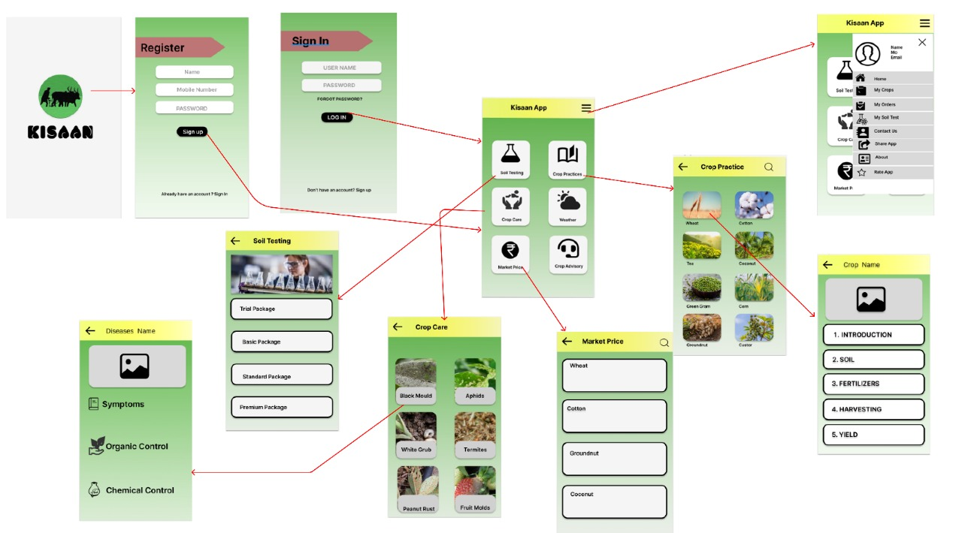

**Flow Chart :**

**Class Diagram:**

**Sequence Diagram:**

**Use Case Diagram:**

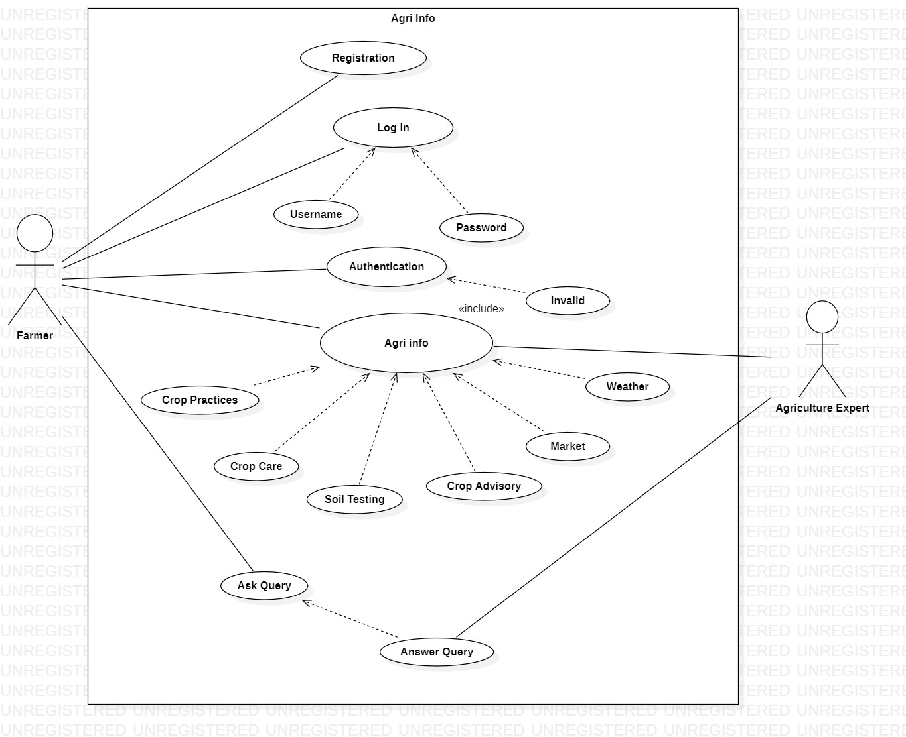

**DFD Diagram:**

Level 0:

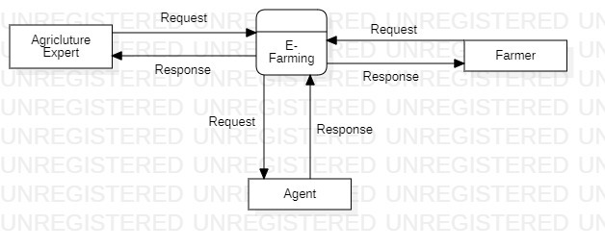

Level 1:

Level 1.1:

Level 1.2:

Level 2:

Level 2.1:

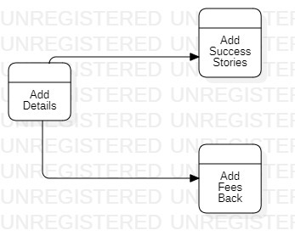

Level 2.2:

Level 2.3:

